Lesson 06 Lesson-End Project

Configure an Action Group to Notify Azure of Any Issues

Project Agenda: To configure an action group to notify events within the Azure infrastructure

Description: You have been assigned a project to create activity log alerts for events within the Azure infrastructure. Additionally, you need to configure an action group to notify team members about the events that occur.

Tools required: Azure account with administrator access

Prerequisites: VM

Expected Deliverables: Add a screenshot showing the configured alert, action group, and alerts generated once the event has occurred.

Steps to be followed:
- Create an activity log monitor
- View activity log alerts in the Azure monitor

Step 1: Create an activity log monitor

- Search for and select Monitor after signing into the Azure portal

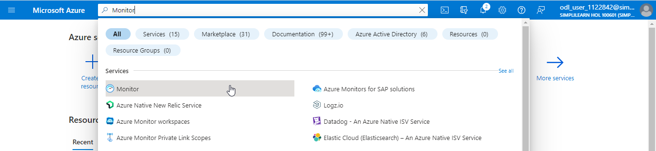

- On the Monitor page, click on Alerts

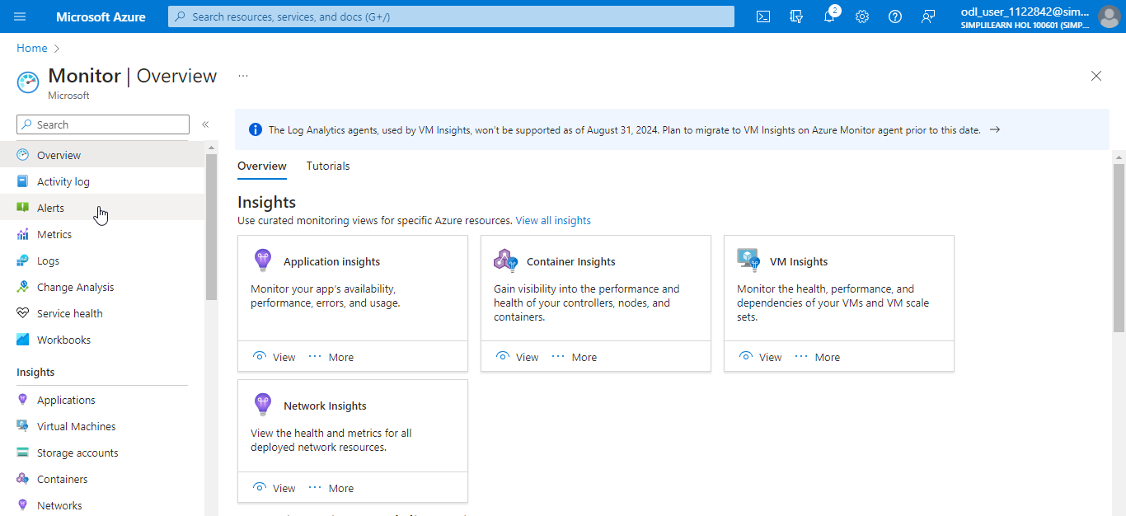

- In the Alerts page, click on the + Create dropdown and select the Alert rule

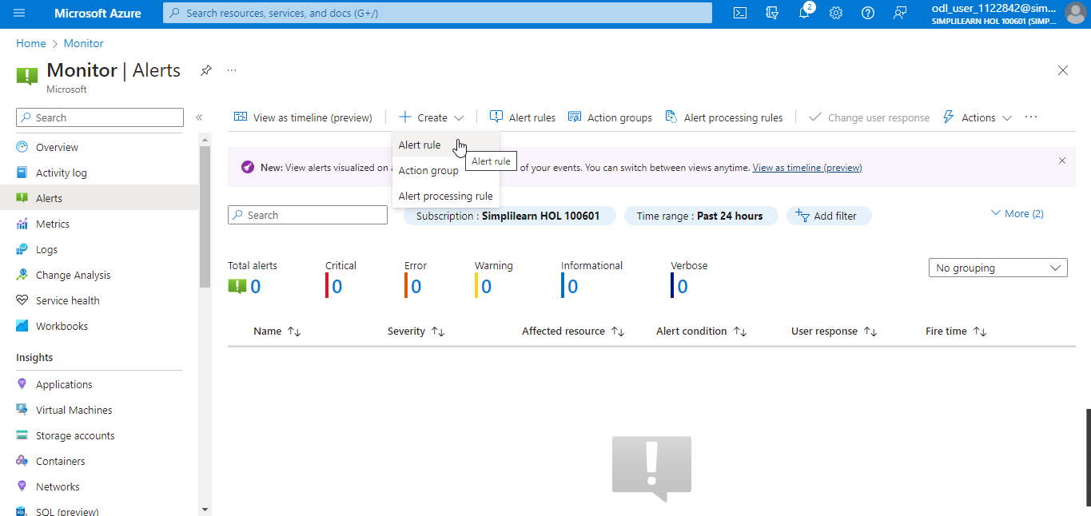

- In the Create an alert rule page, navigate to the Scope tab and click on + Select scope. In the Select a resource section, provide the details as shown in the screenshot and click on Apply.

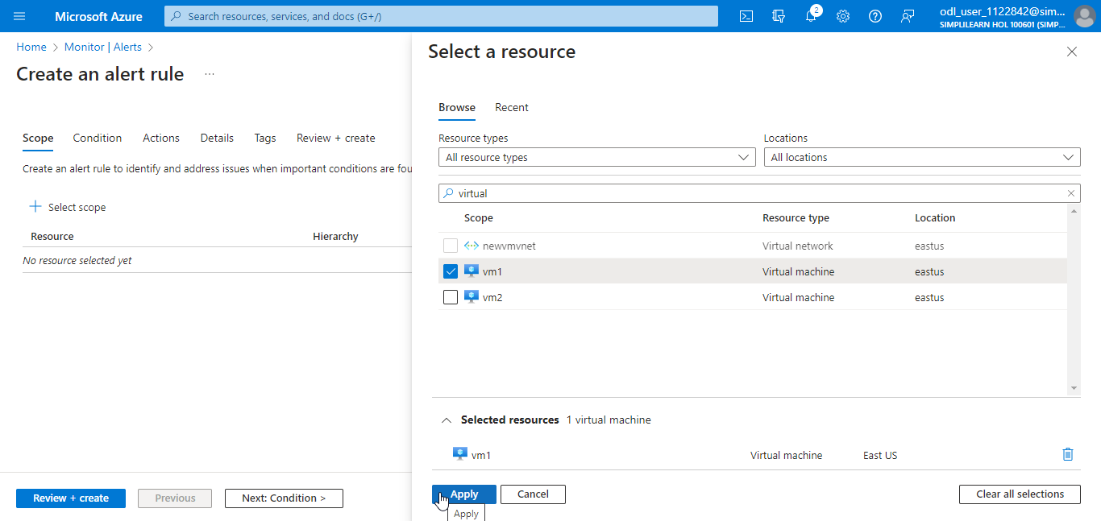

- Click on Next: Condition >

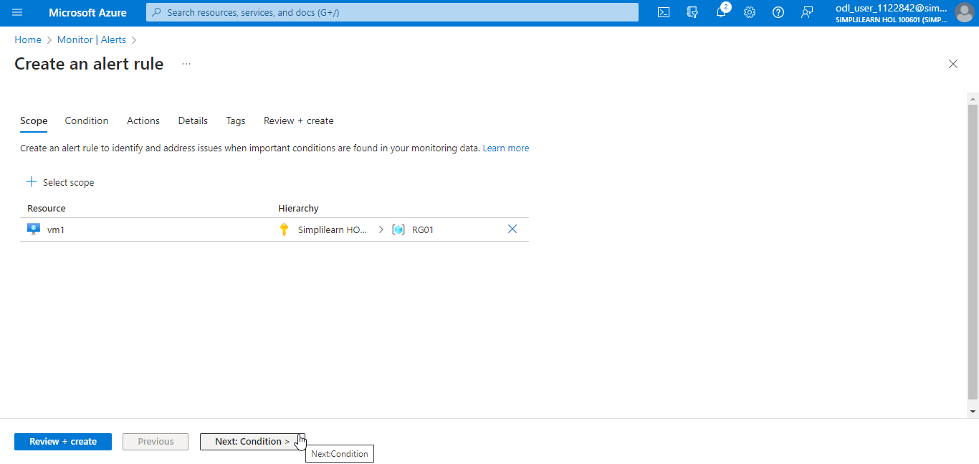

- Under the Condition tab, click on See all signals

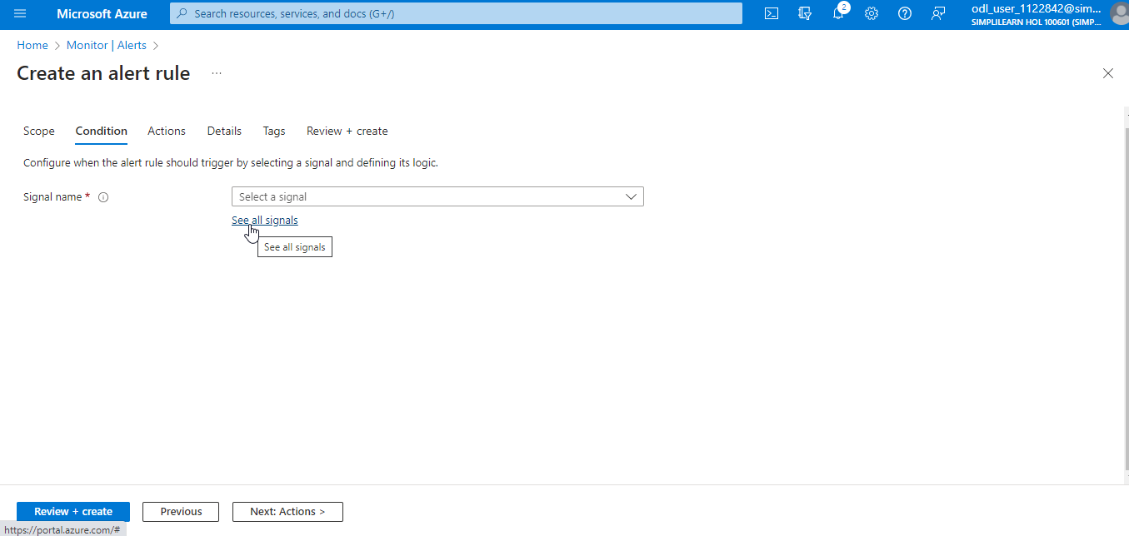

- In the Select a signal section, search for and select Delete Virtual Machine (Virtual Machines), and click on Apply. Now, click on Next: Actions >.

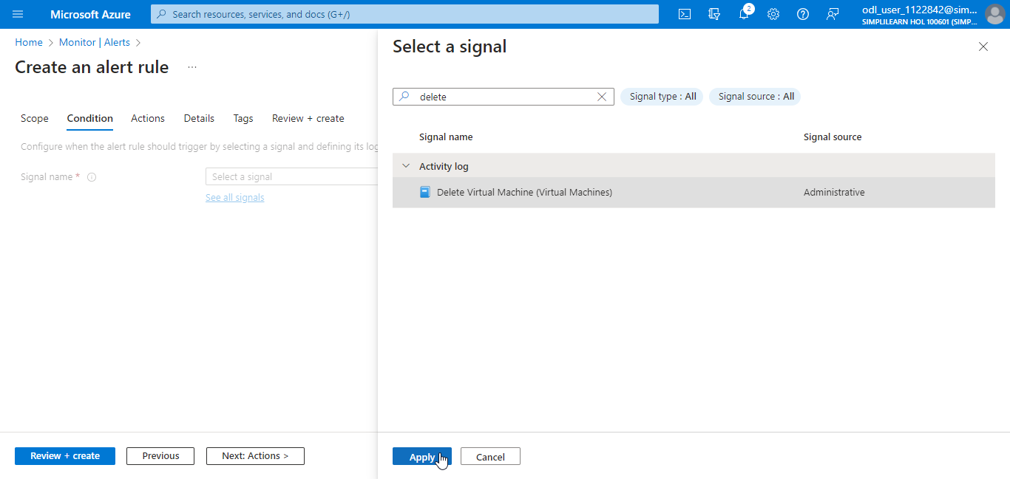

- In the Actions tab, click on + Create action group

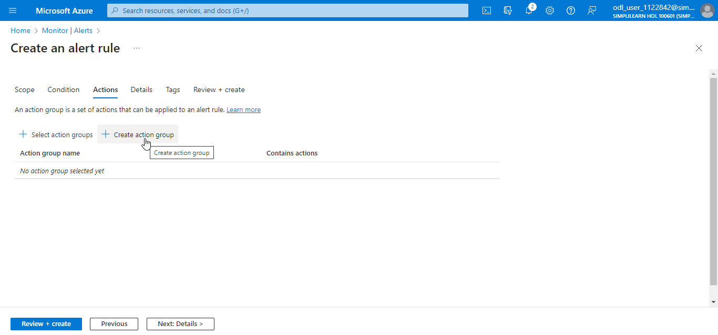

- Under the Basics tab in the Create action group page, provide the details as shown in the screenshot below and click on Next: Notifications >

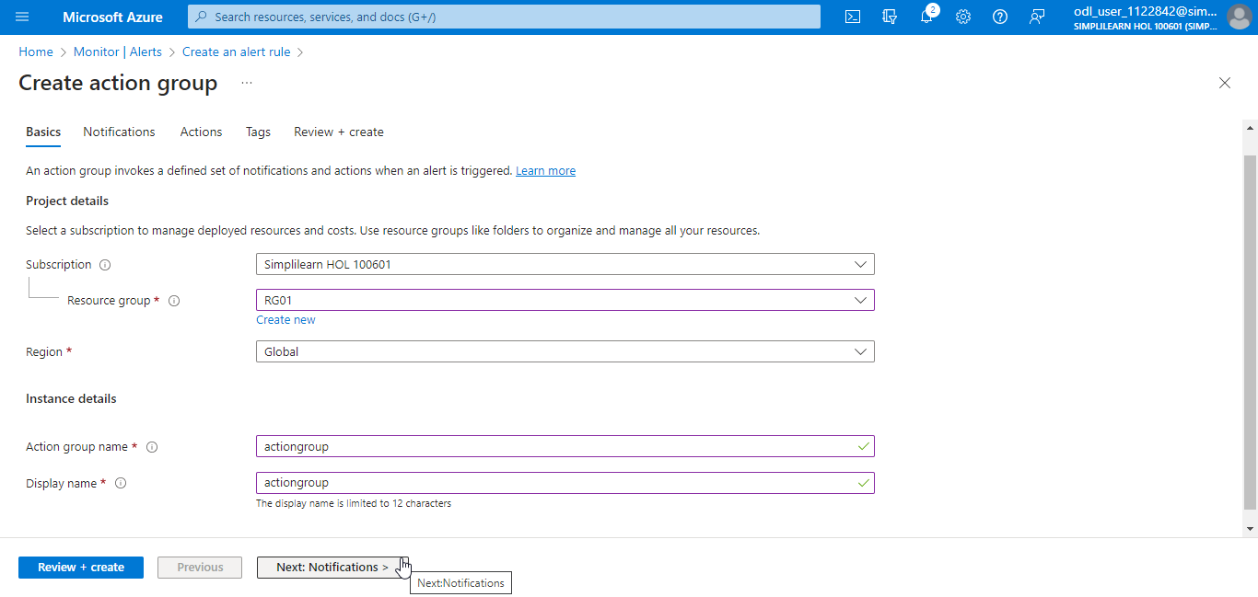

- In the Notifications tab, under Notification type, click on Email/SMS message/Push/Voice

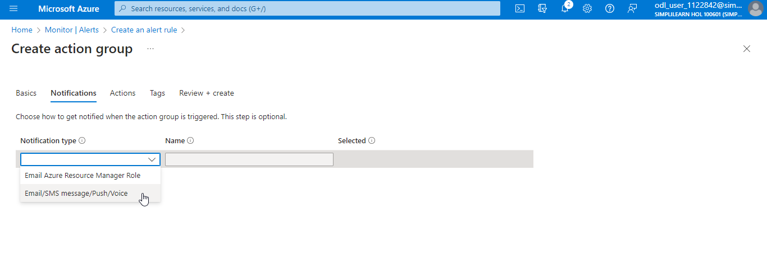

- In the Email/SMS message/Push/Voice section, provide an email address and click OK

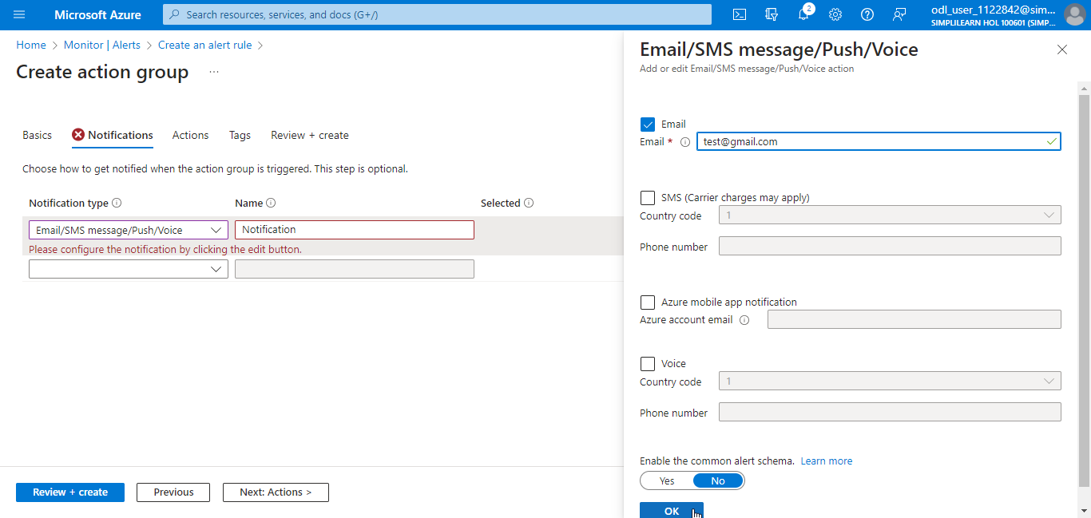

- Provide a Name, click on Review + create, and then click Create

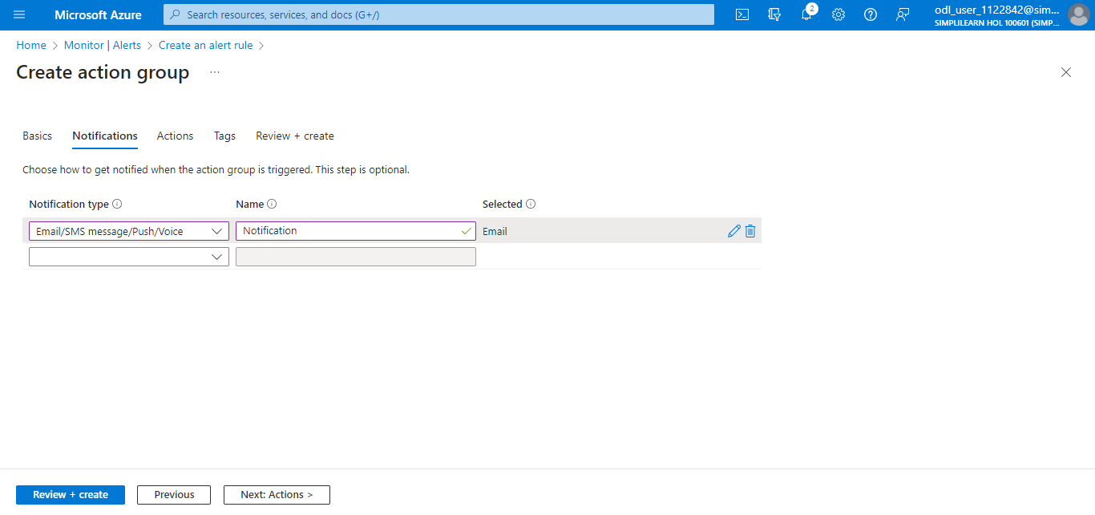

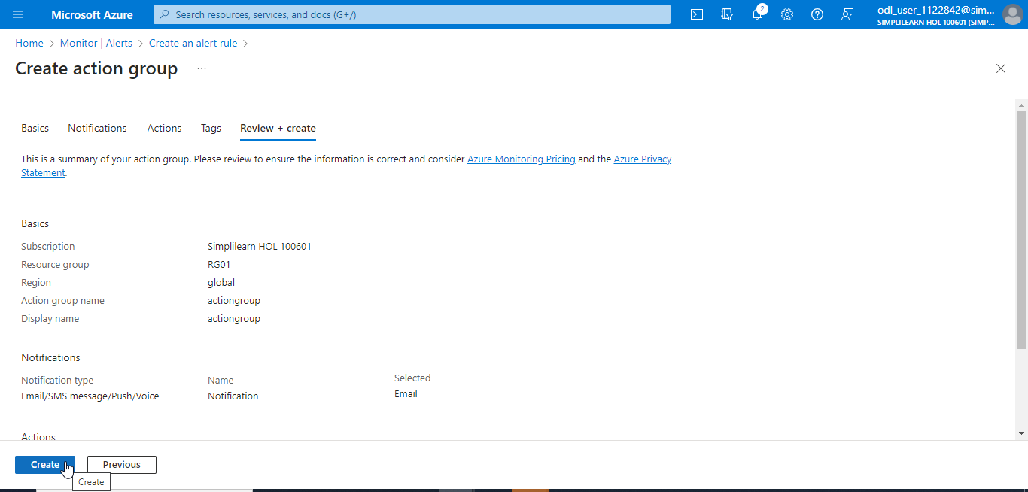

The action group has been created successfully.

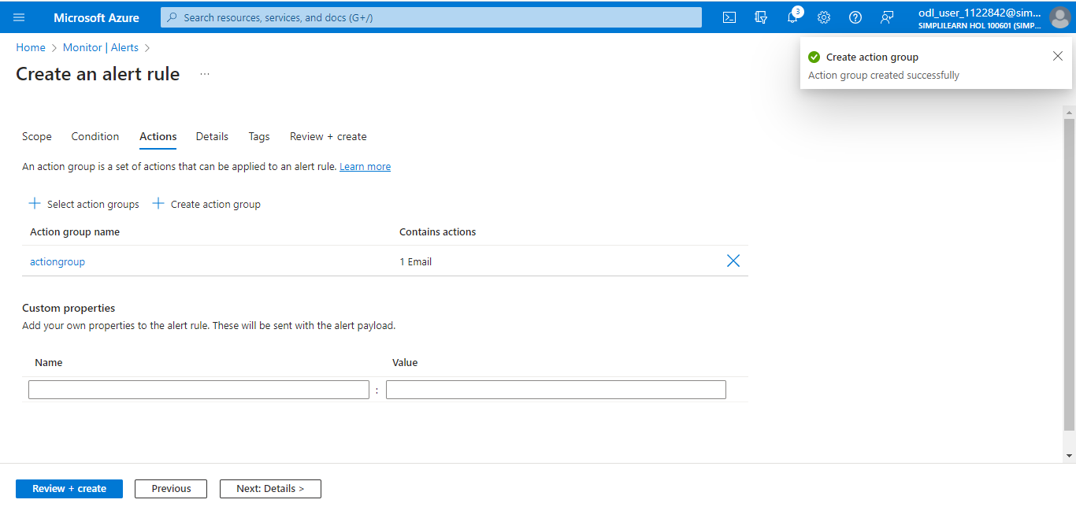

- In the Details tab, provide the details as shown in the screenshot, click on Review + create, and click Create

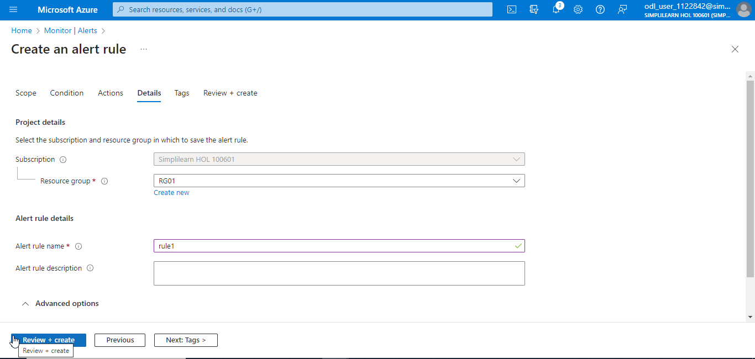

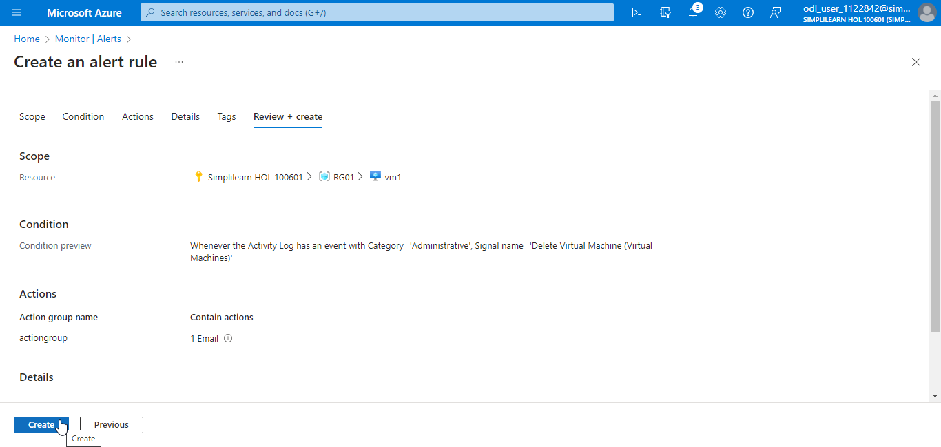

Step 2: View activity log alerts in the Azure monitor

  - Click on Delete to delete the previously created VM (vm1)

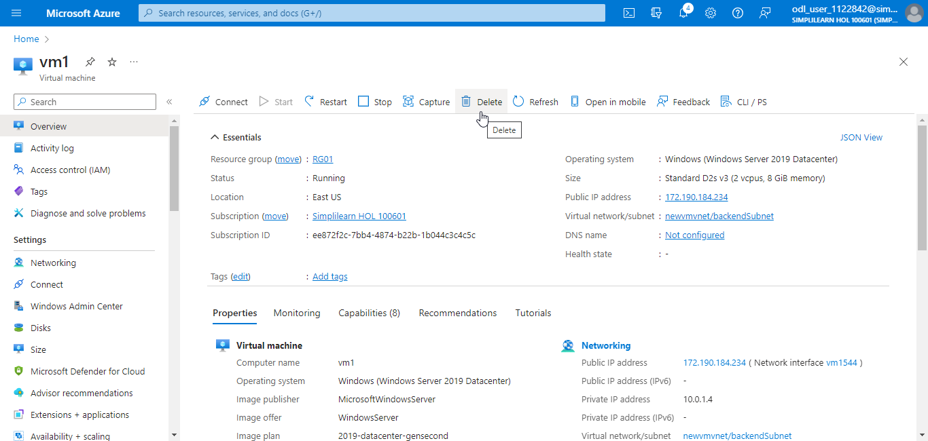

  - Click on Delete

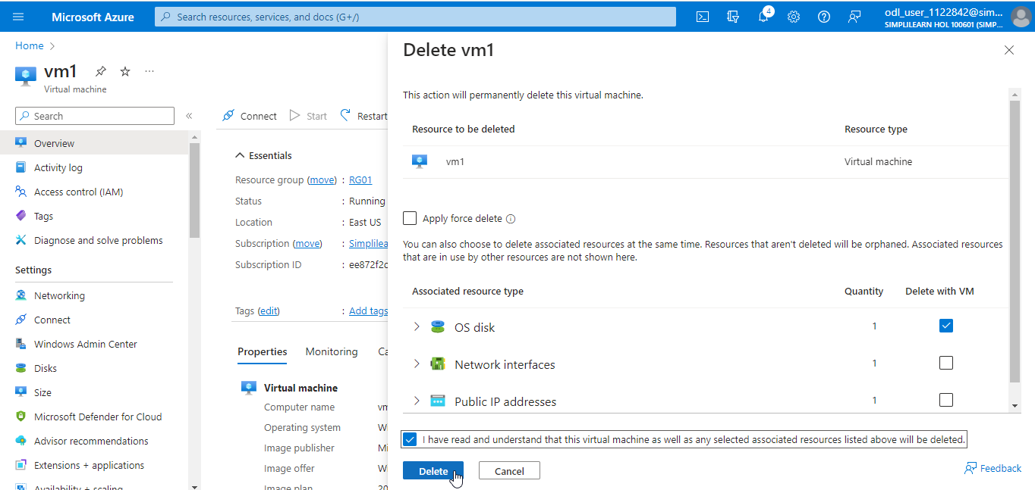

  - Navigate to the Monitor page and click on Alerts

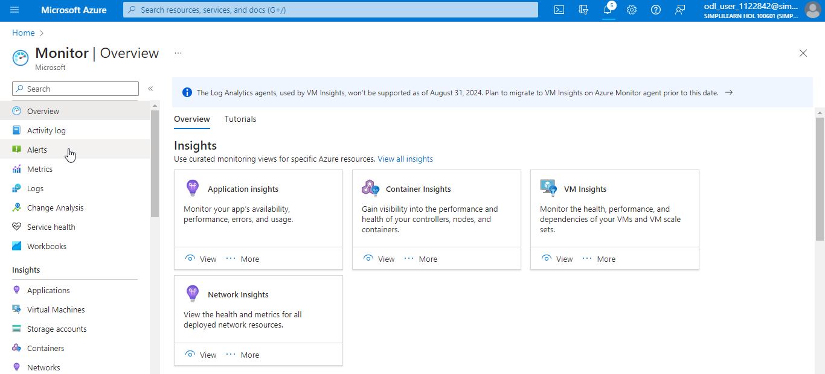

  - Click on Total alerts to view the alerts generated, and select one of the alerts generated

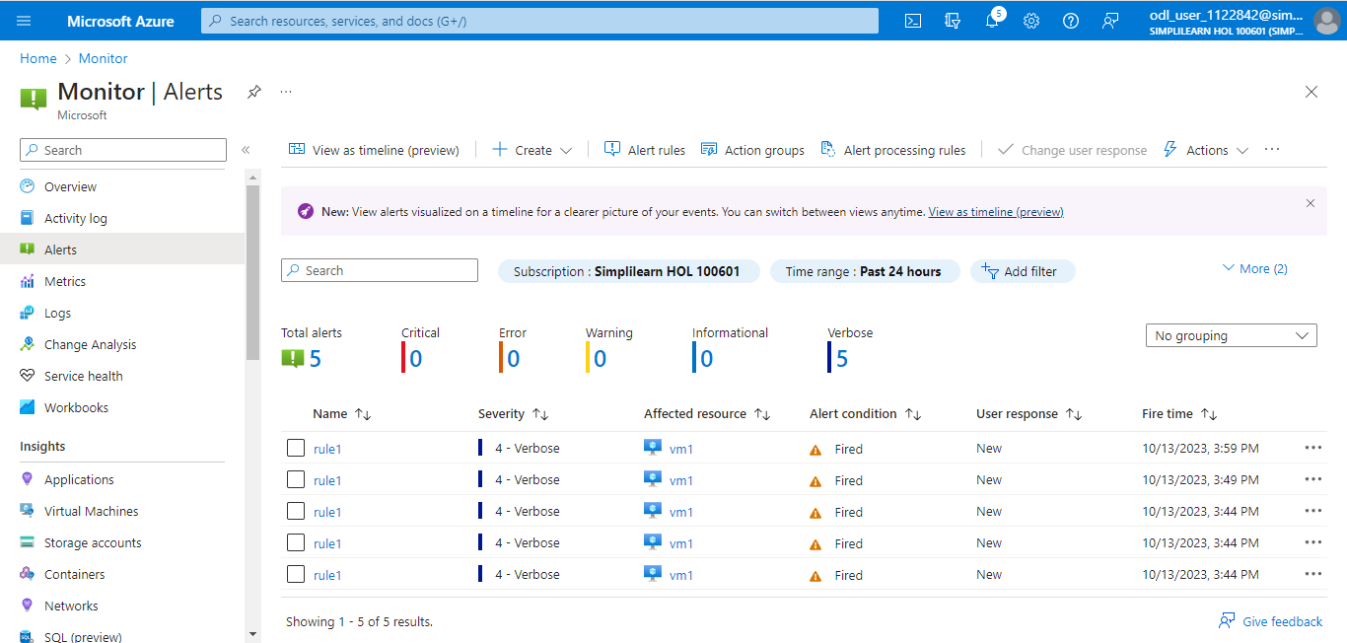

  - On the Alert rules page, click on rule1 to view the summary of the alert

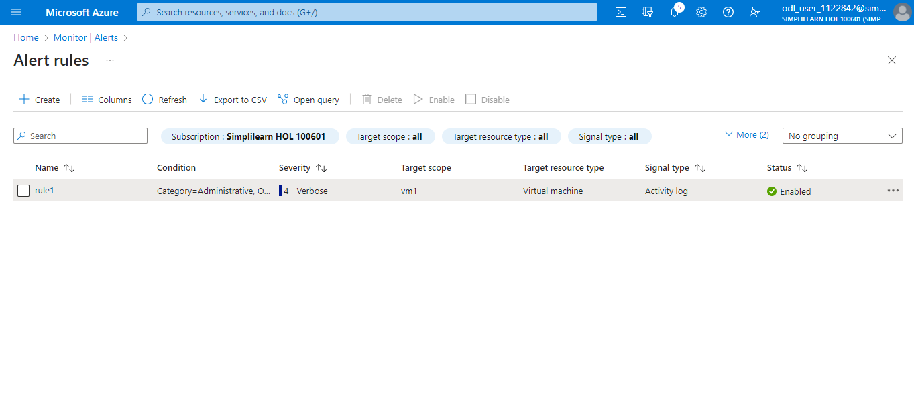

The output will look as follows:

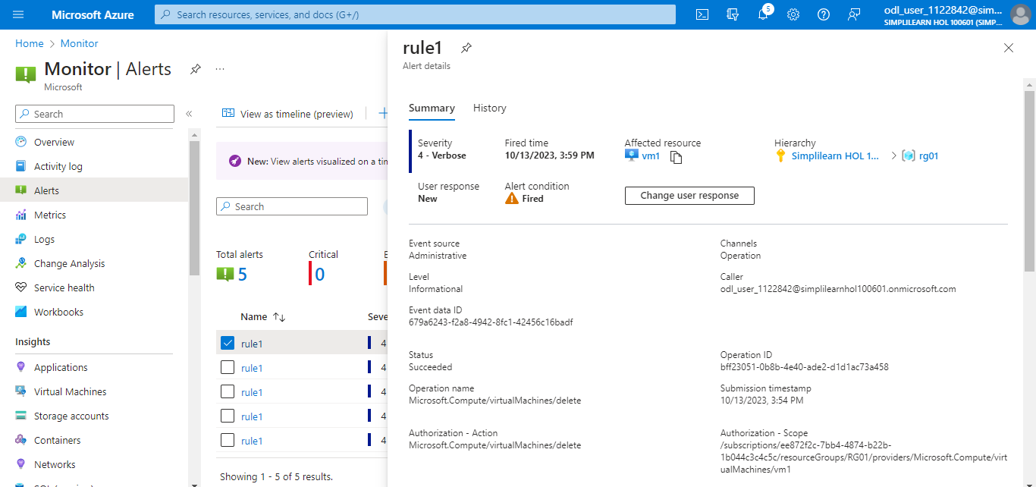

With this, you have successfully configured an action group to notify events within the Azure infrastructure.

